[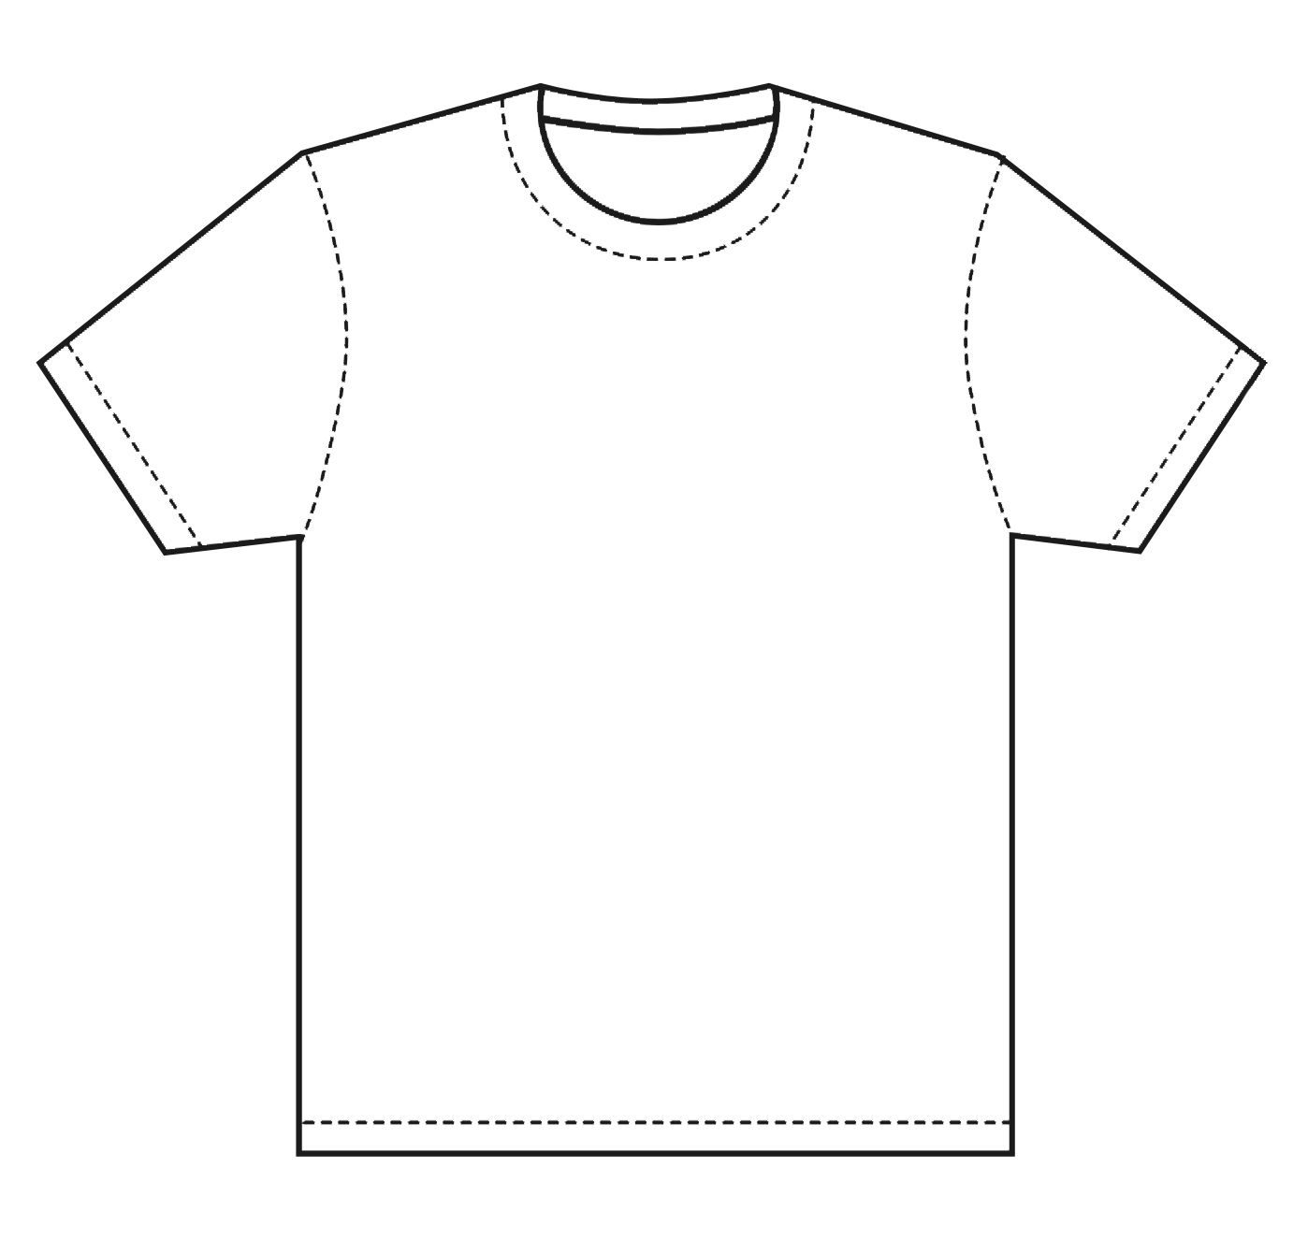](https://www.google.com/url?sa=i&url=https%3A%2F%2Fwww.pinterest.com%2Fpin%2F230316968425336134%2F&psig=AOvVaw30mzYZGdVoZzVCFUReY6PK&ust=1590661946228000&source=images&cd=vfe&ved=0CAIQjRxqFwoTCPCcu9Tr0-kCFQAAAAAdAAAAABAI)